**Overview**

The Banyu Urip Field contains hydrocarbons in two reservoir systems. The clastic reservoir contains oil and an initial gas cap and overlies the older carbonate reservoir, which contains oil with little or no initial gas cap. The oil is 32API (0.8654 gm/cc) with an initial gas-oil ratio (GOR) of approximately 66.8 m3/m3 (375 scf/STB). The separator gas contains 1.55 mol% H2S and 45.26 mol% CO2.

The development plan consists of 49 wells comprising 30 carbonate oil producers, 4 clastic oil producers, and 15 injector wells. Current drilled only for carbonate oil producers

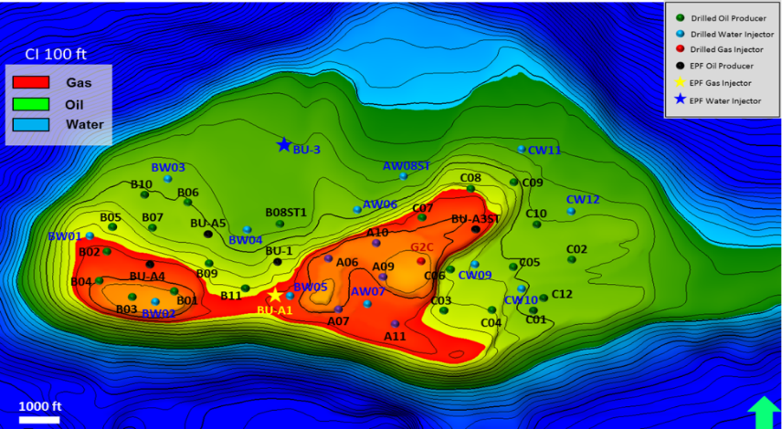

There is a joint work within UTC-engineer and business users to maximize oil recovery, eliminate non-productive user’s time and increase profitability through the design and deployment of integrated workflows. These activity will combine business process with advanced UTCS techset and engineering expertise to streamline and automate the execution of tasks performed by cross-functional teams. The current surveillance plan objective are:

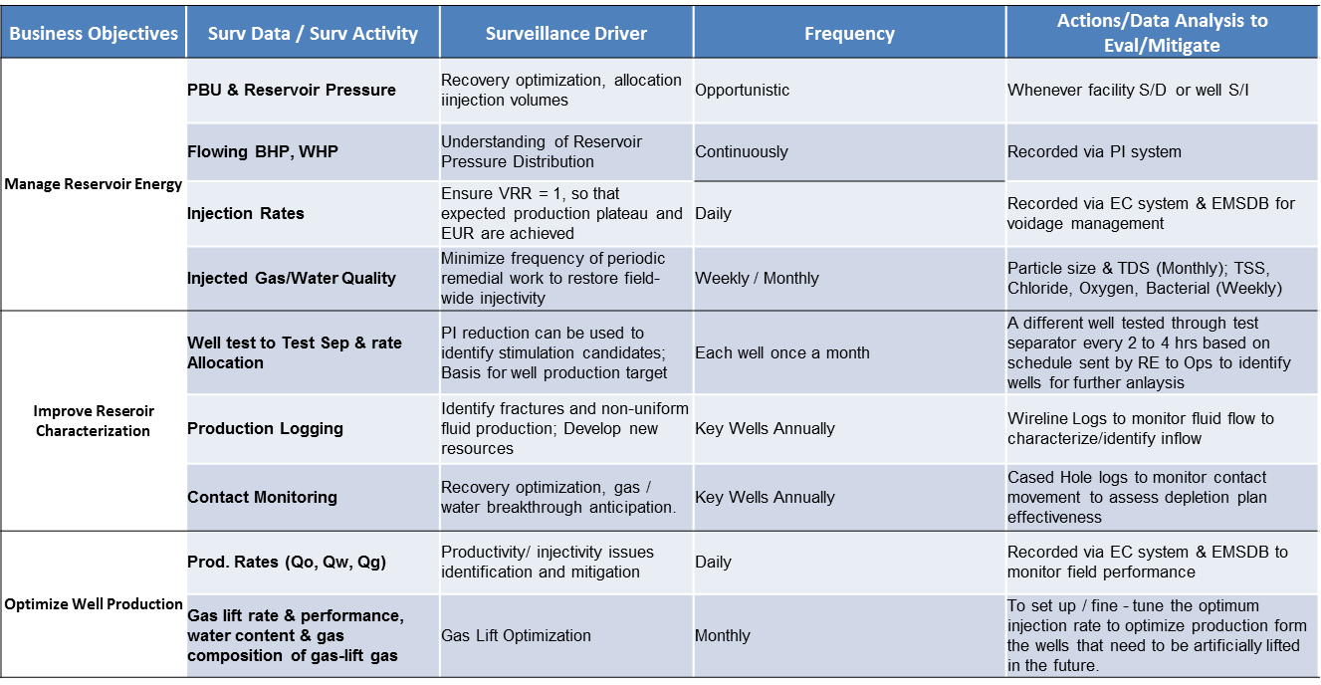

1. Production target managed as per drawdown strategy; No water nor gas BT
2. Pressure has been declining 1.6 psi/Mbo and gas cap has been moving downwards (withouth water injection). Currently saw some pressure response after pressure injection from producers and injectors

|  |  |  |
| --- | --- | --- |
| **Data Acquisition** | **Frequency** | **Remarks** |
| ***All Wells*** | | |
| PBU, Step Rate Tests | Opportunistic | Whenever facility shut-down/well shut-in or facilities or well start-up |
| BHP, WHP | Continuously | Recorded via PI system |
| ***Producers*** | | |
| Field Prod. Rates (Qo, Qw, Qg) and Water Salinity | Daily | Recorded via EC system & EMSDB |
| Well-test to Test Sep | each well once a month | 24 hrs test on each well |
| ***Injectors*** | | |
| Well Injection Rates | Daily | Recorded via EC system & EMSDB |
| Injected Water Quality | Monthly | Particle size, TDS, TSS, 12 ions |
| Pressure Falloff Tests | as required |  |

**Activity**

The expected outcome are on reservoir surveillance and reporting enhancements. The users has come up with sort of wish list and urgency.

|  |  |  |  |
| --- | --- | --- | --- |
| **Priority** | **Job** | **Tools** | **Resource** |
| Medium | Daily morning report automation | ovs | EC |
| Medium | Weekly report automation | ovs | EMSDB |
| Medium | PEPC BKS prod update automation | ovs | EC & EMSDB |
| High | Fluid Properties link to | ovs | EMPOWER |
| High | VRR plot | ovs,ofm | EMPOWER & EMSDB |
| High | Hall Plot | ovs,ofm | EMSDB |
| High | Wellbore Utility Review | ovs,ofm | EMSDB |
| Medium | SBE - Pressure limits, WIMS Dashboard* | ovs | EMSDB |
| Medium | Reservoir & WIMS pack Automation* | ovs | Materials Available on OVS |
| High | Automate FBHP @MPP | OVS, RPM | EMSDB |
| High | Bubble Map | OFM | EMSDB |

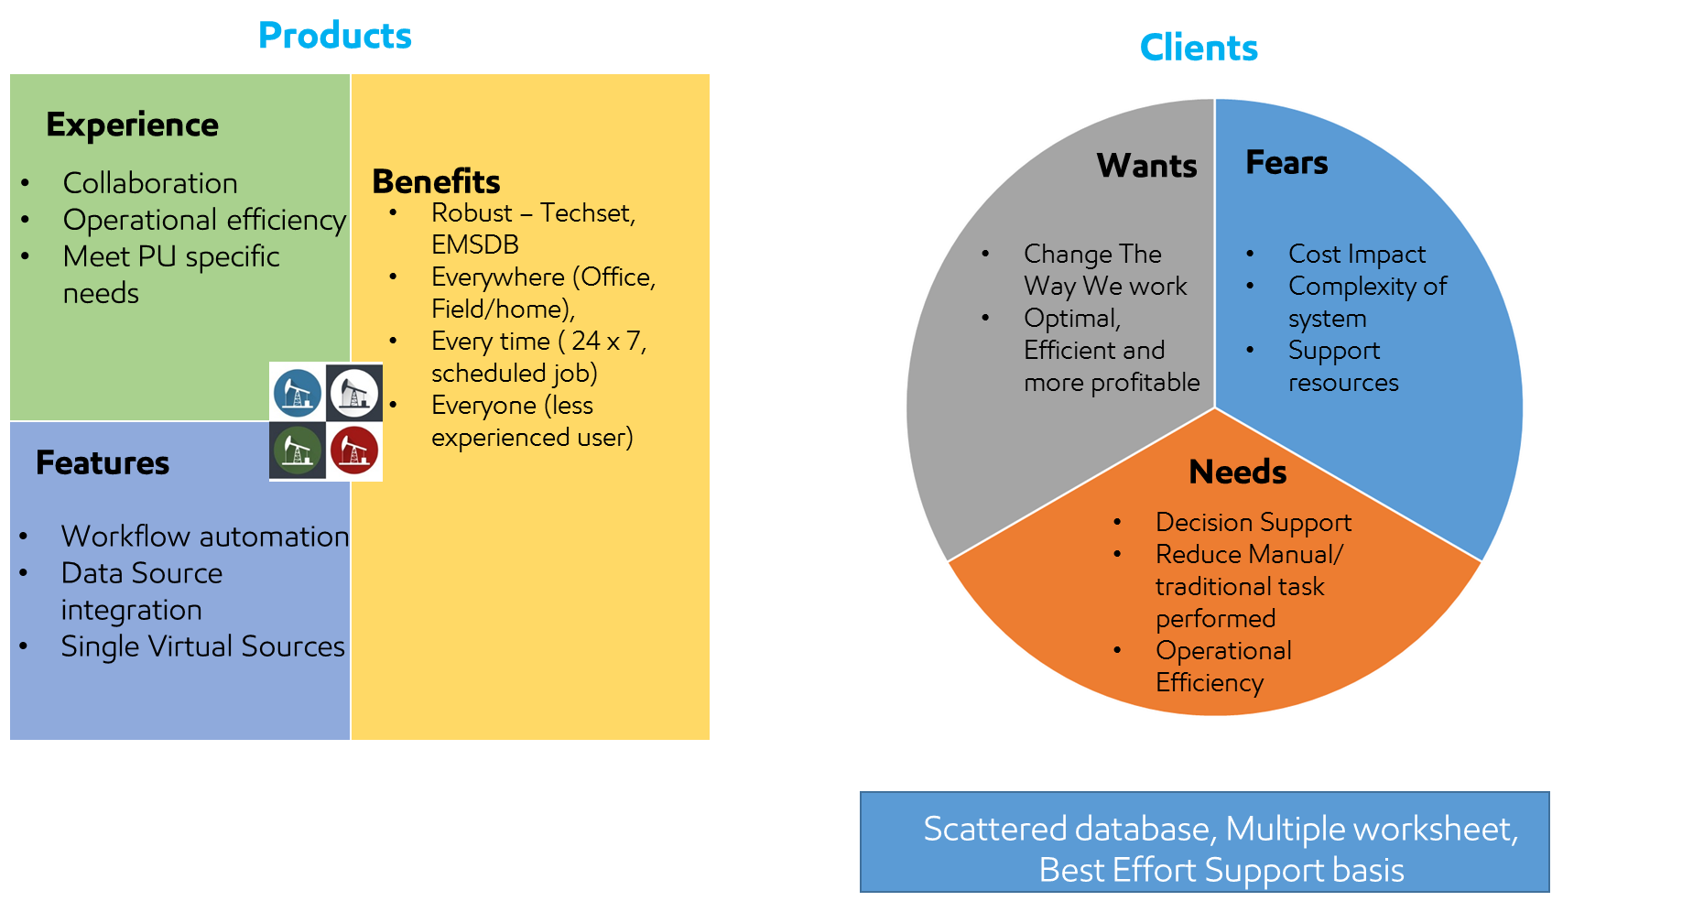

1. **Waterflood monitoring**

Hall plots are used to monitor injection wells. Use of these plots helps to maximize water-injection rates, which accelerates oil production from offsetting producers. On a Hall plot, the bottomhole injection pressure is plotted vs. cumulative water injection to monitor reservoir fill-up and average-reservoir-pressure increase.

The Hall Plot analyzes steady-state flow at an injection well. In general, the slope of Hall plot is interpreted as an indicator of the average well injectivity. At normal conditions, the plot is a straight line. Kinks on the plot indicate changes of injection conditions.

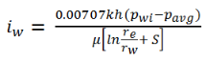

At this point, it is assumed that k, h, μ, re, rw and S are constant.



Data Sources:

* EG Table: Flowing BHP for each Completion, Injection Cumulative Daily, injection days

Asset >Water Injection >> Daily Hall Plot / Monthly Hall Plot

Required to take attention

|  |  |
| --- | --- |
| **Daily Hall PlotC:\Users\r9zuhru\Pictures\Daily Hall Plot 1.jpg** | **Monthly Hall Plot**  **C:\Users\r9zuhru\Pictures\Monthly Hall Plot 2.jpg** |

1. **Voidage Rate Replacement**



Using this formula calculation as per 2016 (No water and gas BT)





Template users wants

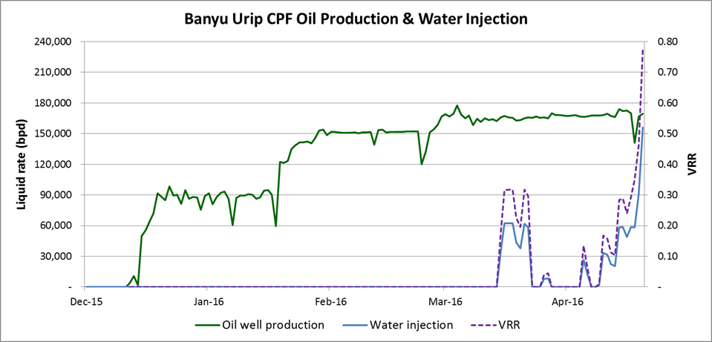

Required automated workflow

* Reservoir Pressure calculation – maximum value based on latest well test
* PVT data store
* Daily VRR Calculation

1. **Wellbore Utility Review**

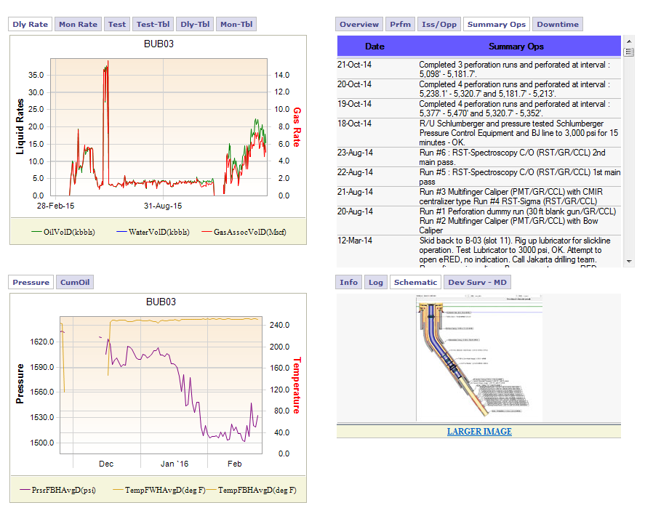

Required automated workflow

1. Surveillance by exception validation “ WIMS dashboard”
2. EMpower for saturation map and forecast result
3. Well test result consolidation
4. Open Hole log and Cased hole log? Contact movement database
5. Any IPM things related? Well test data to VLP/IPR matching through Open server
6. Requires to connect High Frequency data e.g. PI ?
7. Comments / recommendation from Production Engineer
8. **Map (grid, bubble)**

Required to have bubble/ grid map for surveillance, with these variables:

* Gas Oil Ratio
* Water Cut
* Cumulative Production
* Pressure
* Pie chart of Oil and Water of each well
* Productivity Index

Thinking to integrate EMSEE usability also

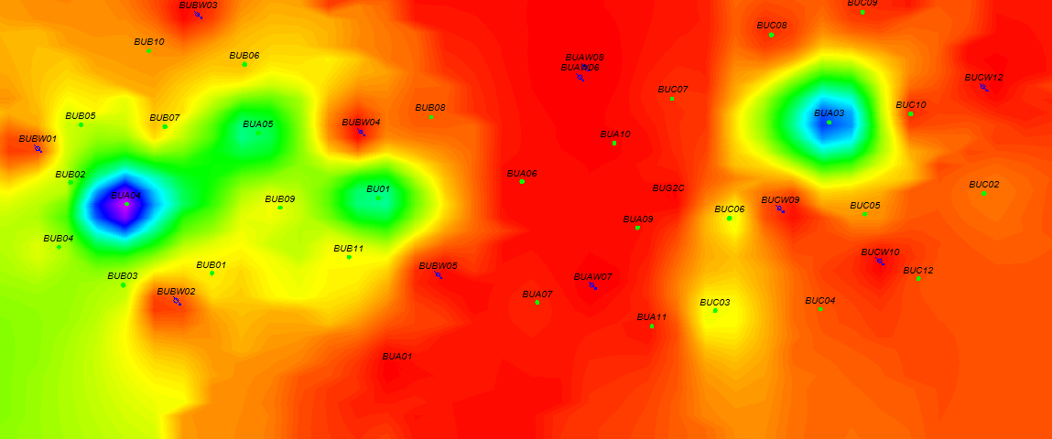

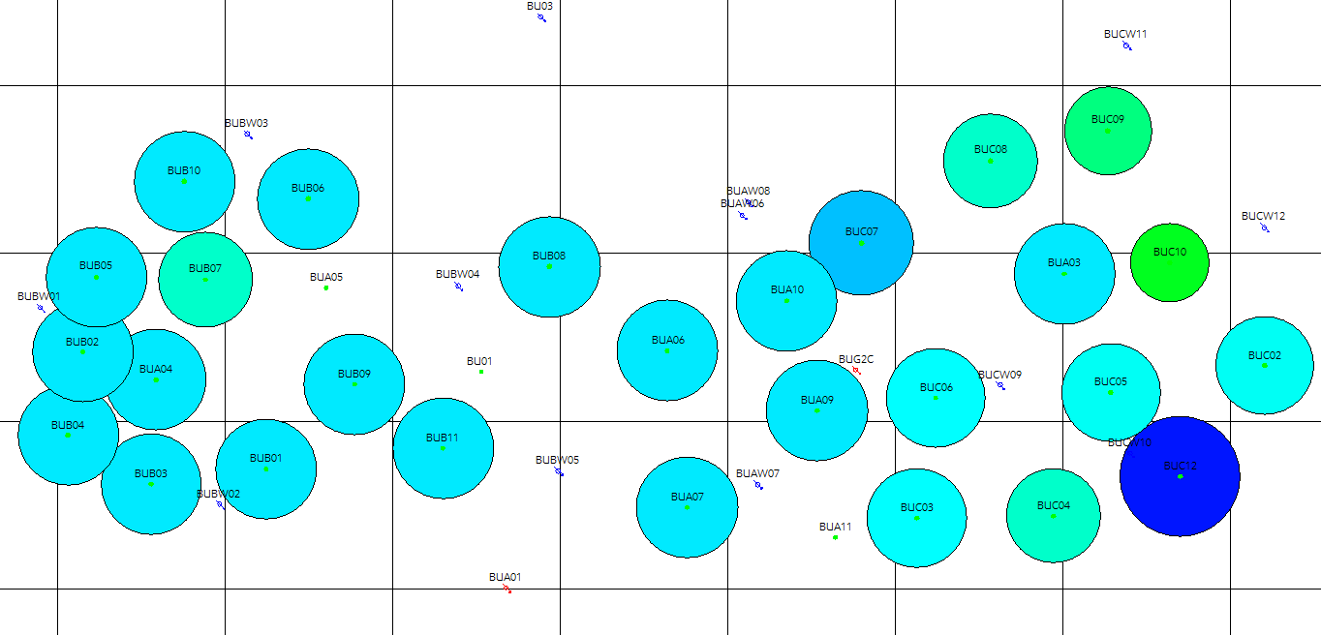

Required automated workflow

1. Flowing BHP @mid perforation
2. Productivity Index calculation